Community Legal Education Collaboration Fund 2024

A: Guidelines
B: Application form

2022
Legal Aid Queensland (LAQ) established a grants fund, the CLE Collaboration Fund, to resource and support the development of new collaborative community legal education (CLE) initiatives and resources. This is part of our Community Legal Education Strategy.
LAQ administers the fund, the Department of Justice and Attorney-General (DJAG) funds it and a decision-making panel comprising LAQ, a Community Legal Centres Queensland (CLCQ) nominated representative and other legal assistance sector members reviews all the submitted project proposals.

Community legal education — why it’s important
- A legal system is less fair when people do not understand their legal rights and responsibilities. CLE aims to address this by informing and educating the community about the law.
- Litigation is costly financially and emotionally. Intervening early when legal problems first arise can help reduce costs in the justice system. Many legal problems can be resolved more easily and at less cost if they are addressed in the early stages.
- CLE helps people find out where they can get legal assistance when they need it. CLE helps to reduce barriers that stop vulnerable people from accessing legal help.

Fund objectives
To fund CLE initiatives and projects within the legal assistance sector that:
- promote collaboration between legal assistance and community support/ frontline services
- help people identify legal problems early, understand their legal rights and responsibilities, and how to get legal help.
The fund objectives align with the National Legal Assistance Partnership 2020-25 (the NLAP). Under the NLAP, all state, territory and Commonwealth governments undertake collaborative service planning with the legal assistance sector (the sector) to coordinate and maximise reach of services and to ensure that services are directed where they are most needed.

Eligibility criteria
Grants are available to organisations in Queensland that are:
- currently receiving state or Commonwealth funding to deliver legal assistance services under the legal assistance services program; it is expected the body accepting legal and financial responsibility for the project will be incorporated under relevant legislation
- Regional Legal Assistance Forums (RLAFs) or Specialist Legal Assistance Forums (LAFs) where LAQ or one of the incorporated member organisations is willing to accept legal and financial responsibility for the project
- the Aboriginal and Torres Strait Islander Legal Service (ATSILS).
If your organisation has applied for funding in previous funding rounds, you are still eligible to apply for this round. Each application will be assessed on its individual merits.

Funding available
$100,000 in 2024.

Project grants
Eligible organisations are invited to submit project proposals for grants up to a maximum of $30,000 per project.

Project grant criteria
Project proposals must:
- involve collaborative partners or multidisciplinary work teams or be an initiative of a Legal Assistance Forum (LAF) (outline how you will work with LAQ and/or other legal assistance and community-based services to deliver the project)
- focus on Commonwealth and state legal assistance priorities – see NLAP 2020-25
- be client focused, accessible to priority audiences
- respond to community legal needs
- avoid duplicating existing CLE resources and services
- have clearly defined goals and outcomes
- use resources wisely and be sustainable
- include a process for collecting data that informs evaluation
- be based on adult learning principles and good practice CLE
- be innovative and creative.

Examples of projects that will be considered
- Multimedia and digital education resource development eg online resources including videos, legal information factsheets and guides, information kits, training modules and legal information guides.
- Podcasts, radio shows, CLE theatre and storytelling projects.
- Face-to-face CLE activities/engagement/events for community members and/or community workers.
- Online legal information sessions delivered via webinar or other technology.
- CLE projects that focus on increasing awareness of legal issues within priority communities.

See examples of resources that have been produced through the CLE Collaboration Fund.
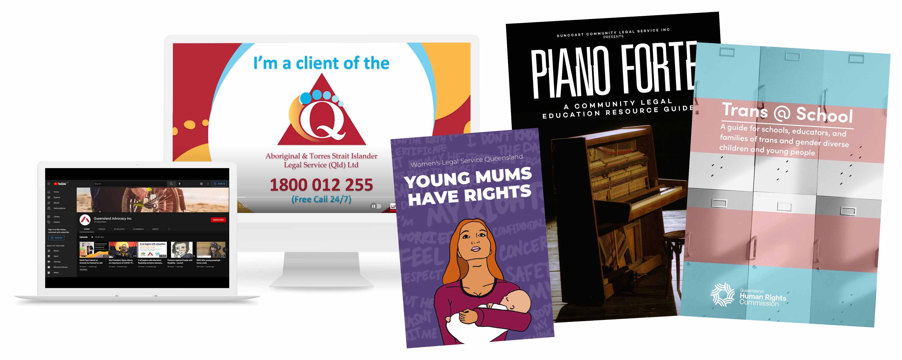
Community legal centres and LAFs previously awarded CLE Collaboration Fund grants are encouraged to reapply for a grant to extend or expand their funded project.

Grant conditions
- Project grants are capped at $30,000 (excluding GST); LAQ will award a maximum of $30,000 (excluding GST) to each successful project. Where collaborative partners submit separate grant applications for a joint project, the total project grant budget must not exceed $30,000 (excluding GST).
- All grant amounts requested must be GST exclusive. If your organisation is GST registered, an extra 10% GST will be added to your grant amount.
- Grant amounts requested must be in whole dollars.
- Please contact the CLE and engagement coordinator if you discontinue your project or if at least $1000 of your project grant is unspent at the end of your project. Remaining project grant monies may need to be returned to Legal Aid Queensland.
- All grant recipients are required to submit a final project report using the template provided.

Eligible costs for inclusion in the project budget
Eligible costs are operating costs specifically related to the project such as:
- operating expenses (eg staffing, venue hire, catering, production, talent)
- administrative expenses
- accommodation and travel expenses
- production of project materials
- catering.

Non-eligible costs are:
- capital costs (eg office equipment, office accommodation)
- existing project debts
- recurrent items (eg newsletters, subscriptions).

Timeframes
- Fund opens for applications: 4 March 2024
- Applications close: 29 April 2024
- Applicants notified of outcome: June 2024
- Grants distributed to successful applicants: by 30 June 2024
- Projects start date: 1 July 2024

Grants up to $5000:
- Projects must be completed within 12 months of grant allocation.
- Grant recipients must submit a project report (using LAQ’s project reporting template) to LAQ within two months of their project completion date.

Grants over $5000:
- Projects must be completed within 24 months of grant allocation.
- Grant recipients must submit a project report (using LAQ’s project reporting template) to LAQ within two months of their project completion date. LAQ may seek an update on your project’s progress about 12 months after your grant is allocated.

Submitting applications
Before you submit your application:
- express your interest to the CLE and engagement coordinator at LAQ katherine.gorter@legalaid.qld.gov.au

- work through a project planning process. Watch our video to learn how to prepare your grant application and give it the best chance of success.
To apply, please submit a completed application form, addressing the fund guidelines outlined above. Please include supporting letters from partner agencies. Applications must be submitted by email to: cle@legalaid.qld.gov.au

Accountability requirements
A signed letter of agreement between LAQ and the funded agency is to be completed.
Projects conducting CLE activities are expected to evaluate the sessions. A summary of feedback/ evaluation must be submitted to LAQ on the completion of your project.
On the completion of your project all grant recipients must submit a project report to LAQ using the project reporting template provided.
Grant recipients must provide electronic copies of all CLE resources and training materials (eg PowerPoint presentations, handouts, training kits/ materials, link to videos) produced in the project to LAQ. LAQ can help promote these through our various channels including social media.

More information
For more information or to discuss your proposal ideas, contact CLE and engagement coordinator Katherine Gorter on 3917 0457 or katherine.gorter@legalaid.qld.gov.au

Legal Aid Queensland CLE Collaboration Fund application form
Please complete this application form and email it to cle@legalaid.qld.gov.au

Your details
Organisation (Lead agency – if LAF)
Address
Contact name
Phone
Email address

Previous funding rounds
Have you received a CLE Collaboration Fund grant before? Yes No
If yes, what was the grant for? (title of the most recently funded project)

Checklist
The eligible/lead organisation is a member of one of Queensland’s RLAFs or specialist LAFs – please name__________________________________
The project meets all of the conditions and criteria noted in the fund guidelines. If not, please outline what conditions and criteria will not be met and why.___________________________
The eligible/lead organisation has completed all sections of this application form.

The project proposal
Title:

Please provide a description of the project which outlines:
  - the audience/client priority groups
  - what you will do and the identified need for the project. (One page maximum. Arial font, Size 11)

Priority audience:

CLE project description:

Collaboration and consultation (please note it is a condition of this grant that you collaborate with another community agency or work across disciplines/ teams in your own agency/ LAF)
Please name your project partner/s and describe how you will work either interdisciplinary and/or collaborate with LAQ and/or other legal assistance and/or community-based service partners to deliver this project (please attach letters of support):

Project grant details
Project grant requested: $ |  | (Amount requested must exclude GST and be in whole dollars)
Is your organisation registered for GST? Yes No
Will your organisation contribute extra funding to the project budget? Yes No
If yes, give details.
Will you seek payment from CLE session attendees? Yes No Not applicable
If yes, give details and include an estimate of this income in the project budget table on the following page.
Will you seek to recover project costs from other organisations or individuals?
Yes No If yes, give details.

Budget
Please complete the table below with the following information:
- Column A: an itemised budget for the project (figures must be GST exclusive)
- Column B: an itemised estimate of in-kind contributions your organisation will attribute to this project, for example office rent, utilities, insurance, accounting/audit fees and IT maintenance/support.
Please note Legal Aid Queensland will not provide funding for in-kind expenditure incurred by your project.
Project budget description | Column A:  Project budget ($) | Column B:  In-kind contributions ($)
Income
Grant income
Other income/funding
Total income
Expenditure
Total expenditure
Project balance | $ | $

Consultation and environmental scan
Note: To avoid duplicating CLE resources and initiatives, please outline the consultation and/or environmental scan you have completed to identify the service gap or need for this project (dot points are ok):

Expected project outputs and outcomes
Please outline your expected project outputs and outcomes:
Outputs:

Outcomes:

Promotion
Please outline how you will promote your CLE sessions, resources or initiatives to the priority audience:

Evaluation
How will you evaluate the project? How will you know it has been successful?

Timeframes
Project start date
Project end date
Brief comment on sustainability of the project | Eg ongoing use/availability of resources developed during this project

Declaration
Submitted by authorised officer
Position
Date
Please email this completed application form to cle@legalaid.qld.gov.au

