



**How do I ask for a review about my ABSTUDY debt?**

# Contents

##### Page 3

When should I use this guide?

##### Page 3

What is an ABSTUDY debt?

##### Page 3

Can I get legal advice?

##### Page 4

Asking Centrelink to review their decision about your ABSTUDY debt

##### Page 5

Request for review of an ABSTUDY debt

##### Page 7

Submitting the form

##### Page 7

What happens next?

##### Page 7

What if I don’t agree with Centrelink’s review decision?

##### Page 8

How to apply to the Administrative Review Tribunal for a review

##### Page 9

Sample document and form



**Disclaimer**

This guide is intended to provide you with information only. If you have a legal problem, you should get legal advice from a lawyer. Legal Aid Queensland believes the information provided is accurate as at November 2024 and does not accept responsibility for any errors or omissions.

We are committed to providing accessible services to Queenslanders from all culturally and linguistically diverse backgrounds. If you would like this publication explained in your language, please phone the Translating and Interpreting Service on 13 14 50 to speak to an interpreter. Ask them to connect you to Legal Aid Queensland on 1800 998 980. If you are deaf or have a hearing or speech impairment you can contact us using the National Relay Service. Visit [www.relayservice.gov.au](http://www.relayservice.gov.au/) and ask for 1800 998 980 (our legal information line). These are free services.

# When should I use this guide?

Use this guide if:

* Centrelink tells you that you have an ABSTUDY debt
* you’re not happy with their decision about your debt
* you want to ask Centrelink to review their decision
* you want to apply for an external review of Centrelink’s decision/s.

You should ask for a review within **three months** of the date Centrelink decided you have an ABSTUDY debt.

If it has been more than three months since Centrelink decided you have an ABSTUDY debt, you can still ask Centrelink to review the decision, however, you will also need to apply for an extension of time.

# What is an ABSTUDY debt?

If you were studying and receiving ABSTUDY, but then stopped studying for whatever reason and kept receiving ABSTUDY, then you might have an ABSTUDY debt.

There can be other reasons for having an ABSTUDY debt too, like if you had income that Centrelink didn’t consider when they paid you ABSTUDY.

If Centrelink says you have an ABSTUDY debt, they will want you to pay it back.

# Can I get legal advice?

It is always a good idea to get legal advice about your ABSTUDY debt. A lawyer can help you fill in the form needed to ask Centrelink to review their decision about your debt. They can also explain your options if you’re not happy with the outcome of Centrelink’s review.

You can get free legal advice from Legal Aid Queensland – call the Aboriginal and Torres Strait Islander Hotline on 1300 65 01 43.

**How do I ask for a review about my ABSTUDY debt? 3**

# Asking Centrelink to review their decision about your ABSTUDY debt

If you’re unhappy with a Centrelink decision you can ask for a review.

You can ask for a review of a debt even if you have already paid the money back. It’s free to ask Centrelink for a review.

## Is there a time limit?

Yes. You should ask for a review within **three months** from the date Centrelink decided you have an ABSTUDY debt. For other types of Centrelink debts there is no time limit for asking for a review. The three-month time limit only applies to ABSTUDY debts.

If it has been more than three months since Centrelink decided you have an ABSTUDY debt, you can still ask Centrelink to review the decision, however, you will also need to submit an extension of time application.

## How to ask for a review

You can ask Centrelink to review their decision about your ABSTUDY debt in the following ways:

#### Option 1. Call Centrelink and ask them for a review

You can call the Centrelink ABSTUDY line on 1800 132 317 Monday to Friday from 9am to 5pm. You can talk to someone about your debt and ask them to lodge a request to review the decision over the phone. If it’s more than three months since Centrelink decided you have an ABSTUDY debt, you should also ask for an extension of time.

#### Option 2. Fill out an ABSTUDY debt review form

We think it’s best to ask for a review in writing. You can use the form on the next page to ask for a review of your ABSTUDY debt. Copy and paste the text on the next page into a new document and type your answers, or print and fill out by hand. See the sample form on page 9.

# Request for review of an ABSTUDY debt

* If you need help filling in this form, call Legal Aid Queensland on 1300 65 01 43.
* Type your answers or write neatly in black or blue pen.
* Make sure the information you include is correct.

I am writing to request a formal review of my ABSTUDY debt of $ ....................................................................................  
Name .................................................................................... Birth date (DD MM YYYY) ........................................

Phone .................................................................................... Centrelink CRN .........................................................

Address ....................................................................................................................... Postcode .................................

I am making this request because: (check all boxes that apply)

I am in financial hardship

I have lots of other debts to repay

I have been sick

My mental health has been poor

Someone in my family has been sick or has had poor mental health

I have had caring responsibilities

I have had big medical costs (or someone close to me has)

I have had other family or cultural obligations or responsibilities

I have experienced significant loss or had sorry business

I have been homeless or had unstable housing

I had lots of trouble with my uni etc which made it difficult to do my study or resulted in other mistakes

I moved away to do study and I was away from my family and other supports

My mail was sent to the wrong place

I have a disability or illness which makes it difficult to understand or follow Centrelink rules

I have difficulty reading and writing

I have had other unusual costs to meet

Something else unusual, out of the ordinary or distressing has happened

I told Centrelink about my situation, but things still went wrong

Centrelink error or delay contributed to my debt

Having a debt has been very upsetting

I would have been able to get a different payment if I had known I wasn’t supposed to be on ABSTUDY during the period of my debt

Give details about the boxes you have checked if you can:

|  |
| --- |
|  |

|  |
| --- |
|  |

If it is more than three months since Centrelink decided I have an ABSTUDY debt, please consider granting me an extension of time because I had special circumstances that stopped me from asking for a review of my debt decision within three months.

I could not request a review of my debt decision within three months because (check all boxes that apply):

I thought there was no time limit to ask for a review of a Centrelink debt decision

I did not know about my ABSTUDY debt

My mail was sent to the wrong place

I tried to talk to Centrelink about my debt, but it didn’t help

I have been sick

My physical or mental health has been poor

Someone in my family has been sick or has had poor mental health

I have had caring responsibilities

I have had other family or cultural obligations

I have experienced significant loss or had sorry business

I have been homeless or had unstable housing

I have a disability which makes it difficult to understand or follow Centrelink rules

I have difficulty reading and writing

Something else unusual, out of the ordinary or distressing has happened

Having a debt has been very upsetting

Not applicable (it’s less than three months since Centrelink decided I have an ABSTUDY debt)

Give details about the boxes you have checked if you can:

|  |
| --- |
|  |

Signature:

Date (DD MM YYYY) ........................................

# Submitting the form

Once you have filled out the form you can:

* give it to Centrelink at one of their offices
* post it to Centrelink at PO Box 7800, Canberra BC, ACT, 2610
* fax it to Centrelink on 1300 786 102
* take a photo of it and upload it to your Centrelink Online account.

# What happens next?

Centrelink will review the decision. An independent review officer will:

* look at whether you should get an extension of time (if relevant)
* look at whether you were entitled to the ABSTUDY payments you were paid at the time
* look at whether Centrelink made a mistake when calculating your debt
* change the decision if they think it’s wrong
* reduce the debt if they think it was caused by a Centrelink error
* reduce the debt if they think you have any special circumstances, and that the debt wasn’t the result of you or someone else knowingly telling Centrelink the wrong thing or breaking the law.

The review officer will write to you to let you know the review outcome.

# What if I don’t agree with Centrelink’s review decision?

If you don’t agree with the review officer’s decision, you can apply to the Administrative Review Tribunal (ART) for an external review.

You should ask the ART to review your debt if Centrelink says:

* you still have to repay your debt or
* you can’t have an extension of time.

**How do I ask for a review about my ABSTUDY debt? 7**

# How to apply to the Administrative Review Tribunal for a review

Call the ART’s first level (Social Services and Child Support Jurisdiction) on 1800 228 333 and ask them to review Centrelink’s review decision. You need to do this within **three months** of the date of Centrelink’s review decision. It is free to apply to the ART.

You can also ask the tribunal to make an appointment for you to get free legal advice from Legal Aid Queensland.

If you’re not happy with the first review decision made by the ART, you can ask for a second review from the tribunal’s General Jurisdiction. You need to apply for a second review within **28 days** of the date of the first tribunal decision. If you apply for a second review, you might be able to negotiate an outcome without having to go to a hearing.

You have to apply in writing for a second review. You can call the tribunal on 1800 228 333 and ask them to send you a copy of the form or you can send an email to [reviews@art.gov.au](mailto:reviews@art.gov.au)

You can also apply online by visiting the ART website at [www.art.gov.au](http://www.art.gov.au/) and selecting “Online services”, “Continue without account” and then “Apply online”.

If you are not happy with any Centrelink decision received, get legal advice. You can call Legal Aid Queensland’s Aboriginal and Torres Strait Islander Hotline on 1300 65 01 43 to make an appointment with a lawyer.

**8 How do I ask for a review about my ABSTUDY debt?**

**SAMPLE**

#### Sample form: Request for review of an ABSTUDY debt

* This is an example to give you an idea of the information you might need to include in your form.
* Do not copy the information on this sample form.
* Use it as a guide only – put information about your own situation on your form.
* If you need help filling in the form, call Legal Aid Queensland on 1300 65 01 43.

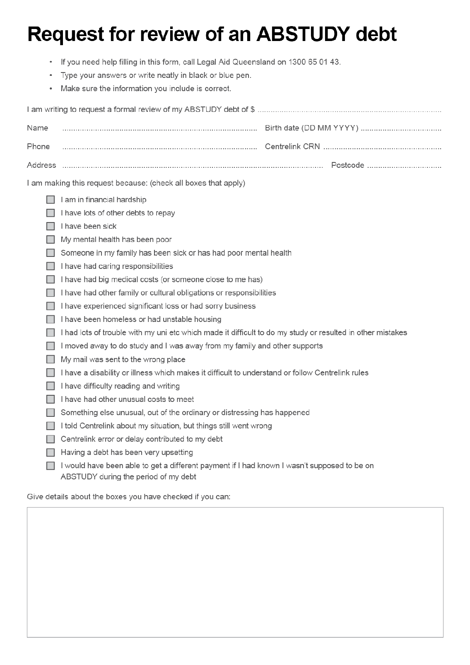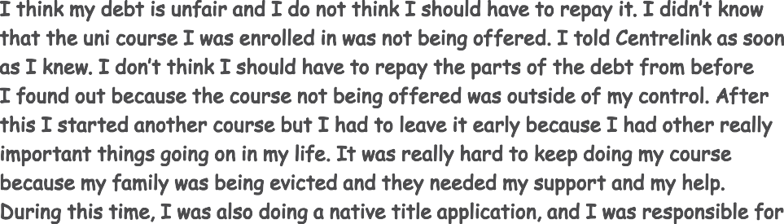

**How do I ask for a review about my ABSTUDY debt? 9**

**SAMPLE**

**10 How do I ask for a review about my ABSTUDY debt?**

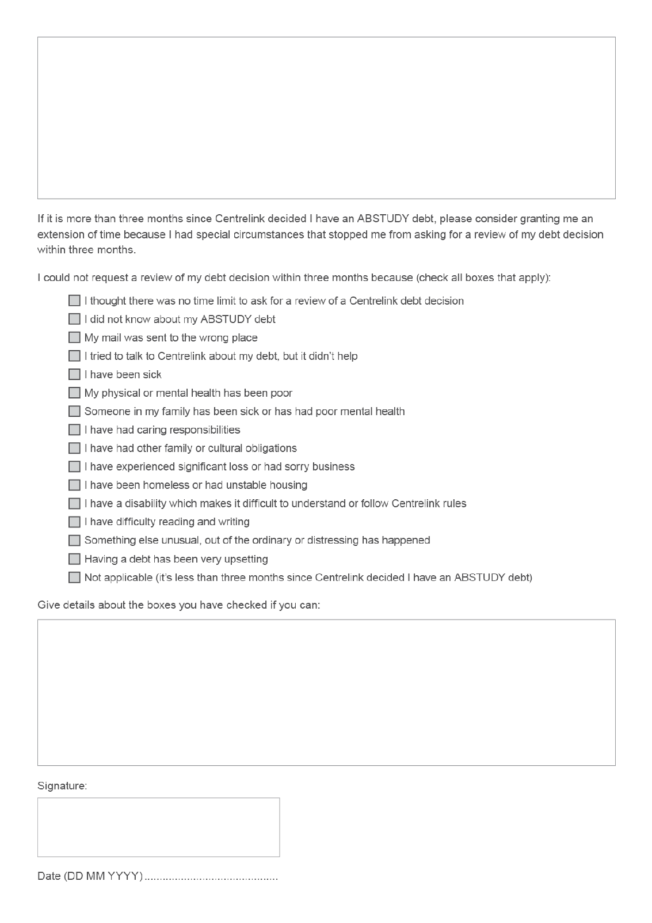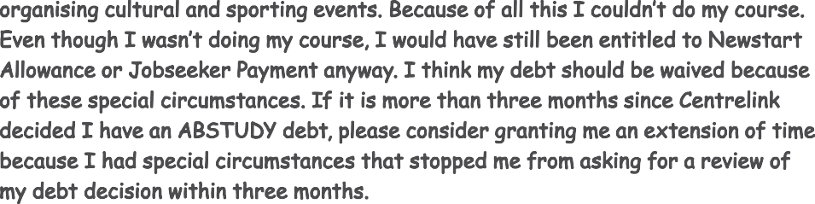

**Your notes**

**How do I ask for a review about my ABSTUDY debt? 11**

**Your local Legal Aid Queensland office**

### Brisbane

44 Herschel Street

BRISBANE Q 4000

### Bundaberg

3rd Floor WIN Tower

Cnr Quay & Barolin Streets BUNDABERG Q 4670

**Caboolture** Ground Floor Kingsgate

42 King Street

CABOOLTURE Q 4510

### Cairns

Level 2 Cairns Square Complex 42-52 Abbott Street

CAIRNS Q 4870

### Inala

Level 1 Inala Commonwealth Offices 20 Wirraway Parade

INALA Q 4077

### Ipswich

Level 7, 117 Brisbane Street

IPSWICH Q 4305

### Mackay

Ground Floor 17 Brisbane Street

MACKAY Q 4740

### Maroochydore

Ground Floor M1 Building

1 Duporth Avenue

MAROOCHYDORE Q 4558

### Mount Isa

6 Miles Street MOUNT ISA Q 4825

### Rockhampton

Ground Floor 35 Fitzroy Street

ROCKHAMPTON Q 4700

### Southport

Level 2

7 Bay Street

SOUTHPORT Q 4215

### Toowoomba

1st Floor

154 Hume Street

TOOWOOMBA Q 4350

### Townsville

Level 4

Northern Securities Building 22 Walker Street

TOWNSVILLE Q 4810

### Woodridge

1st Floor, Woodridge Place Cnr Ewing Road and Carmody Street WOODRIDGE Q 4114





**For more information about our services visit legalaid.qld.gov.au**

LAQ_00XXX October 2024

or phone 1300 65 11 88 or 1300 650 143 (Aboriginal and Torres Strait Islander Information Line)



